**COMPUTER GRAPHICS 1 - Literature Survey 2**

**Primary Paper** - Shadowless Projection Mapping using Retro Transmissive Optics

Kosuke Hiratani* Daisuke Iwai† Yuta Kageyama‡ Parinya Punpongsanon§ Takefumi Hiraki¶ Kosuke Sato|| Osaka University

Link : <https://ieeexplore.ieee.org/stamp/stamp.jsp?tp=&arnumber=10049693>

**Secondary paper -** GoThro: Optical Transfer of Camera Viewpoint Using Retro-transmissive Optical System Yudai Niwa The University of Tokyo niwa@nae-lab.org Hajime Kajita The University of Tokyo kajita@nae-lab.org Naoya Koizumi The University of Electro-Communications koizumi.naoya@uec.ac.jp Takeshi Naemura The University of Tokyo [naemura@nae-lab.org](mailto:naemura@nae-lab.org)

Link : <https://www.media.lab.uec.ac.jp/wp-content/uploads/2019/02/GoThro.pdf>

**ABSTRACT :** (what the paper is about )

In this Primary paper, a shadowless projection mapping system is presented for interactive applications where a user's body regularly blocks the projection of a target surface from a projector. For a serious issue, it has an optical solution that is delay-free. And it specifically uses a large format retrotransmissive plate to project images onto the target surface as the main technical contribution.

This Paper also discusses the specific technological problems with the suggested shadowless principle.

The secondary paper discusses the design and implementation of the GoThro system, including the choice of optical components, the calibration process, and the algorithm used to transfer the camera's viewpoint. Authors also conducted experiments to evaluate the performance of the system, including its accuracy and latency.

When we analyse the common between the two paper involves in explore the use of retro transmissive optics to improve the performance of optical systems, Retro Transmissive optics are generally used in the first study to remove shadows from projection mapping, and in the second paper, they have utilised to change a camera's point of view. These strategies have the potential to get beyond the drawbacks of current techniques and open up new possibilities for applications in fields including entertainment, advertising, telepresence, and remote inspection.

**Why is this relevant or important :**

As I read, the researcher was able to tell us the importance of projection mapping for augmented reality and shadowless displays which is a difficult technical problem. Both the papers have involved and experimented with Conventional projection mapping techniques that frequently occur due to shadows cast on the projection surface, which can reduce the clarity and realism of the images. retro transmissive optics cannot be avoided in our day to day life , as technology grows retro transmissive optics can be seen in Gaming, entertainment, surveillance and many more

These papers are relevant to each other in terms of the use of retro transmissive optics as a key technology, and both demonstrate the potential of this technology to address specific challenges in different fields. I personally felt retro transmissivity is more important in this generation for all ages.

**Describe the paper :**

In the second paper, they have developed an optical transformation system that makes use of a standard camera, a concave lens, and Micro-Mirror Array Plates (MMAPs) to capture images through tiny holes in walls or other impediments. and they wanted to test the theory that a 3mm hole could be used to take pictures of the area on the other side of a wall. The primary use of this system is to take pictures when we are unable to set up a camera to record what is happening. This remembers me an example of capturing wild animal in forest

For a clear concept please refer to the diagram below :

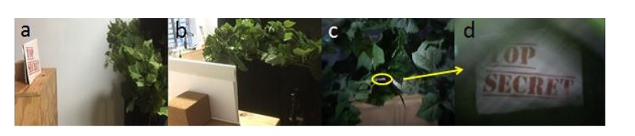

**a,b: set-up at time of capturing. c,d: Images being taken by virtual camera. Image c is taken from front of plant leaves and image d is taken through small gap (yellow circle) in leaves**

With the use of this device, we can take pictures in locations where they are physically unable to set a camera, such as among the remains in disaster zones, etc. How is it possible ?? By Recent developments in the field of computational photography research it is made possible to produce photos with extra characteristics, such as those with depth, a high dynamic range, giga-pixel resolutions, full wavelength, and those taken from a viewpoint around a corner.

Here are the few images of view in varies camera , this can tell how the view are captured in super functionality camera fetched by the researcher

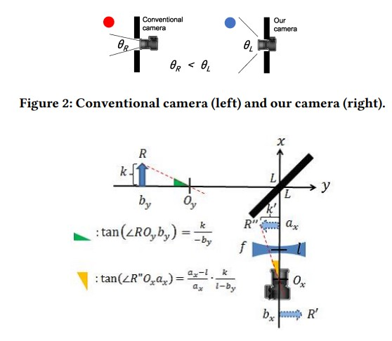

**Optical Design :**

When we see the optical design of a mid-air camera authors are focused in the range of how the images are captured and if it is blurred what's the reason , moreover they come up with a reason for blurring is camera and AIP combined . In the above image first the position of the camera will be converted to the concave lens and the AIP will form as ax→bx→by

by = l − f + f 2 /f − (ax − l) **[ equation 1]**

Perspective wise the concave lens has a non-linear nature with mismatch perspective occurs when the image is captured the size will be analysed in mid air camera and it forms

tan(∠R ′′Ox ax ) = tan(∠ROyby ) **[equation 2]**

By solving above l = 0 **[equation 3]**

In other words, it is necessary to always control the concave lens to align it with the position of the camera lens. Therefore, author’s tried to get distortion-free images by attaching the concave lens to the camera and synchronously moving them

Finally in the angle of view there is a limit to the hole diameter that mid-air camera can capture

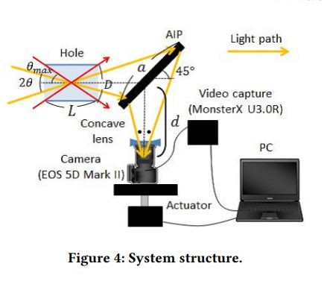

The angle of view θ of the mid-air camera can be expressed as follows using the distance d between the AIP and the camera and the length a of one side of the AIP (square).

tan 2θ = a/ √ 2d

using the thickness L of the obstacle and the hole diameter D, the maximum angle of view θmax of the camera can be calculated as follows.

tanθmax = D/L

With this method, researchers say it is possible to capture images through gaps in debris in disaster sites or through animal cages without disturbing their natural behaviour and a system that works as a mid-air camera positioned through a small hole with a wider angle of view Further in the primary paper Shadowless Projection Mapping using Retro Transmissive Optics) also involves with imaging shadowless projection the main connection between the two papers are imaging using retro transmissive

Here we see an image with shadowless projection mapping using retrotransmissive

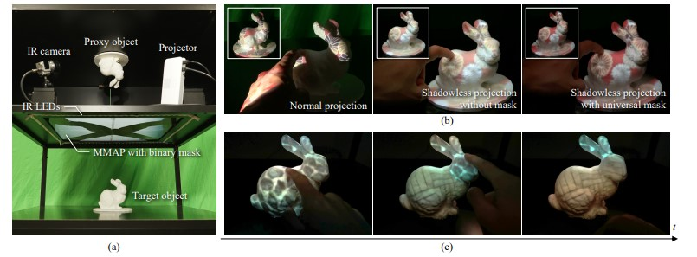

In the image a) Prototype system consisting of a large format retrotransmissive plate (micro-mirror array plate), a projector, infrared LEDs, and an infrared camera

b) ) Projected results in a normal PM system and in the proposed shadowless PM system without and with the proposed spatial mask (c) The system allows a user to interact with projected contents by touching the target object. In this example, the object was divided into three segments (body, head, and ears), and a user specified a segment to change the projected texture by a touch action. See supplementary video for a moving demo .

Main contributions are that researchers introduce a shadowless PM system that optically eliminates shadows on a projection target using a large format retrotransmissive plate, developing a computational approach that optimises the design of a projection target, and introduce a shadowless PM system.

**Shadowless Projection Method :**

Researchers have used MMAP for mapping and it consists of two layers of micro mirrors attached with a glass medium . As in the secondary paper we have sawd same shadowless method implemented by retro transmissive. But in primary paper they have experiment using MMAP methodology

Below image shows the principle of a shadowless projection system using an MMAP. As I understood, MMAP will result in light rays emitting from a point in a space converging at the plane symmetrical point . Image below shows the close appearance of MMAP in (a) and how the ray incident on MMAP is shown in (b) lastly it shows the shadowless projection system in (c)

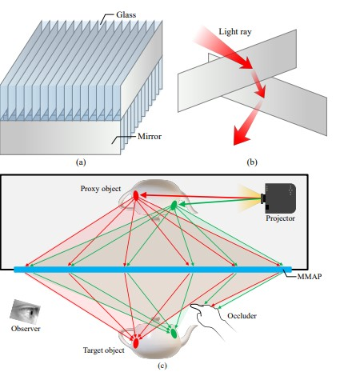

**Experiment :**

To perform the experiment they have used a prototype to validate the shadowless principle . a large retro transmissive plate is placed in MMAP . The distance they have placed the micro mirror is 0.5mm and height of each mirror is 1.5mm , For the proposed system they have implemented IR LED arrays . An IR LED camera is installed such that it can capture the appearance of objects.

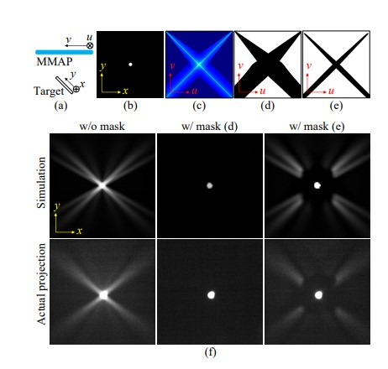

**validation of the computational model :**

1. Shows the Side view of the experiment setup
2. Shows the Projection image appearance in the experiment ,
3. In Ratio of computed radiant flux value

d)Computed mask with a threshold value of λ = 0.0.

e) Computing the mask for a target object

f) Simulation and actual projection results of the dot image without mask

the mask

e) the gain is adjusted for better visibility of the stray light patterns in (f).

**Result :**

Simulated results of projecting the appearances of the natural image “A” without a mask (λ = 1.0) and with masks (λ = 0.24 and 0.1) which will show the masks. mask with λ = 0.24

is the optimal mask. “Target” is computed by removing all the stray

light from the projected appearance. The bottom graph shows E(λ),

the weighted sum of the radiant flux of unblocked stray light and that of

blocked converging light by each mask

In this we can see how the image captured for each criteria with mask or without the mask as shown in the below image example: Simulated results of projected appearances of the natural image

“E” without a mask, with the optimal mask, and the universal mask,

respectively. Insets show the masks. “Target” is computed by removing

all the stray light from the projected appearance. The bottom graph

shows E(λ) values of the three mask conditions (pink is denoting without mask,

blue is denoting with the optimal mask, green: with the universal mask) for each natural image.

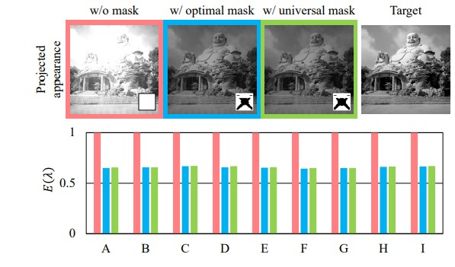

**Universal mask :**

First we can see the projected appearances of a natural image with a mask and the value is λ we generally denote λ as 0.25 value. Secondly, trying using a mask as a mask is optimal for the image and the mask . the result will be image quality . The average and the standard deviation of E(λ)

values with the optimal mask are 0.656 and 7.9×10−3

Those with the universal mask are 0.661 and 8.1×10−3 respectively

**Discussion :**

In this paper it showed the simulation and actual PM experiments and demonstrated the shadow less PM proposal. performed the experiment PM system

applying a large format MMAP rarely exhibited shadows even when

hands covered a target object

* Scalability :

A projection target in PM system is limited to a relatively small object as we used in the experiment

* Image quality:

The image quality is achieved by the luminance and Contrast

* Touch screen:

The advantage of our touch sensing method is that it works with the same optical setup as the projection system

* Shadow less Performance:

current experiment performed in the paper is not having shadow less performance as researcher's exception but can be achieved in future project

**Conclusion**:

In this paper, It shows the delay-free shadowless PM system by applying

an MMAP plate to project images onto a target surface from wide

viewing angles to achieve an occlusion-free interactive PM application.

In addition to the shadowless principle is used in this paper makes the following

three technical contributions. First, To develop a computational

algorithm to design a spatial mask to reduce stray light from the MMAP,

while improving the projected image quality in terms of the contrast

and peak luminance. Second, on the analysis of blurs caused

by the MMAP Finally, a touch sensing technique that estimated user’s touch positions on the target surface from the proxy object’s appearance,

In future they will be improving practical and General shadowless PM system for better technology